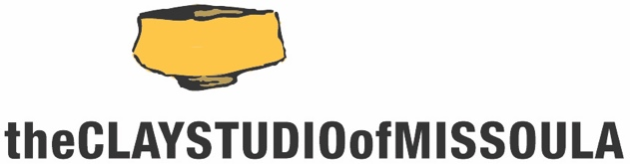

The Clay Studio of Missoula/University of Montana
Summer Residency Opportunity

The Clay Studio of Missoula invites current students or recent graduates* of the University of Montana with experience and an avid interest in ceramics to apply for our Summer UM Residency.

For 3 months during the summer (June-August), the UM Resident will work in the community studio space, which consists of shared general studio area, and be given shelf space to store work and supplies. For the general public, this usually costs $125/mo plus an annual membership, but all these fees are waived for the UM Resident.

- All residents have 24/7 access to the facility
- UM residents will have the same obligations as other residents (studio and gallery duties up to 5 hr/wk, plus create six cups and plates for our Summertime High Tea fundraiser in late August 2020)
- All residents are responsible for material expenses and firing fees
- The UM Resident will be asked to assist with Summer workshops**

There is no application fee for the UM Student Residency. Applicants must complete the application form and include other documentation listed on the application form. Applications are due no later than Thursday April 9, 2020. All applicants will be notified of results no later than the end of April.

To learn more about The Clay Studio of Missoula, please visit www.theclaystudioofmissoula.org. This application can be downloaded from the site in the Residency Application section.

*recent graduates includes any student successfully completing their studies in the 2019/20 academic year
** Scheduled Workshop : Stephen Braun, Saturday, May 30 10am-5pm
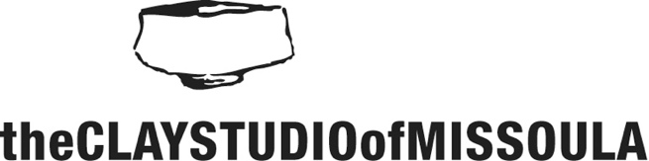 | University of Montana  Student Residency Application  due: Thursday, April 9, 2020
Name:_______________________________________________________________

Mailing Address:____________________________________________________
City:__________________________ State:_________ Zip Code:_____________

Best Contact Phone #:______________________

Email:________________________________ Website:_______________________________ (if available)

Name of one UM ceramics faculty member who supports your application and can speak to your qualifications as a potential resident:

____________________________________________________________________________

Please include the following materials to complete your application:

- Letter of intent indicating your interest in a UM Student Residency at The Clay Studio of Missoula
- 10 high-quality digital images of your work (at 4x6, 300 dpi) sent via Dropbox to info@theclaystudioofmissoula.org by the application deadline
- Image inventory sheet labeled with the title, corresponding number, date, medium and dimensions
- Resume

_____Mark here to confirm you sent your images via Dropbox to info@theclaystudioofmissoula.org

APPLICATIONS MUST BE RECEIVED NO LATER THAN THURSDAY APRIL 9, 2020

APPLICATION MATERIALS MUST BE SUBMITTED BY EMAIL: info@theclaystudioofmissoula.org

If you do not receive a follow up reply within 48 of your submission confirming receipt of your application, please contact us

If you have any questions, please feel free to contact us Email: info@theclaystudioofmissoula.org/ Phone: 406-543-0509

