The Clay Studio of Missoula Wood Fire Internship
Applications due: Friday, August 19 by 5pm

The Clay Studio of Missoula offers several studio technician internships for qualified individuals. Applicants must be self-motivated and have experience with ceramics, with a particular focus and interest in developing their wood firing skills.

In exchange for time and labor, interns receive access to the community studio space, storage area for their work, and the opportunity to further develop their wood fire practice in a supportive community studio setting.

Wood Fire Internship duration is one year, with the option to continue a second year (limit 2 years)

Wood Fire Internship Expectations

- 4 Hours a week Wood Prep/ Kiln Maintenance/ Kiln pad cleanup

- Attend 4 out of 10 classes (classes currently held on Tuesday evenings in the Fall, Winter and Spring)). Perform 2 demonstrations per 10-week class session

- Help make wadding, glazes, and slips for community firings.

- Lead 7+ shifts at the kiln during the 7-day anagama firing

- Expected to make a variety of sized works to help fill kiln

- Attend loading and unloading

- Expected to have a good attitude and interest in sharing information and educating students

- Expected to have some woodfire experience

Intern Perks

- 2 shelves in community studio

- 24/7 studio access

- Works together with the Woodfire Resident making and firing

- Complimentary firings in the wood kiln

Start Date of internship will be no later than Tuesday, September 13 (first Wood Fire Class meeting)

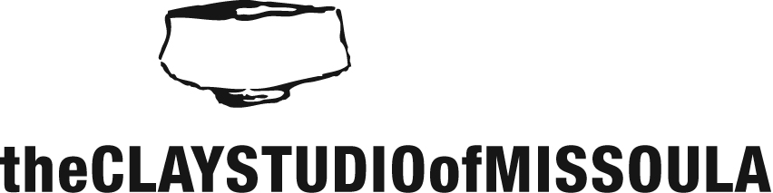

Wood Fire Internship Application

Date: ____________

First Name: ____________________ Last Name:_____________________ Preferred pronouns: ________

Address: ___________________________________________________________________________________

Occupation: __________________________ Date of Birth: ______________

Best contact phone #: ___________________ Email Address: _______________________________________

If you have any previous work and/or volunteer experience please provide a brief summary:

What types of special skills, educational training, and interests do you possess that might assist you in your wood fire internship with The Clay Studio of Missoula?

Which hours and day(s) of the week would you currently be available to fulfill the hours of an internship?

What specific goals/objectives do you have in mind for your wood fire internship?

Please list two people (non-relatives) who can provide a reference for you:

Name: ____________________________ relationship: ________________________
Phone: ______________________ email: ________________________

Name: ________________________ relationship: ________________________
Phone: ______________________ email: ________________________

Our internship program is centered on the idea that through mentorship and education, individuals can gain a broader understanding of ceramic studio practices. It is the goal of the CSoM to offer this program to individuals who would like to advance their ceramic skill levels with guidance from our wood fire resident to achieve a greater level of confidence within your studio practice.

The Wood Fire Intern will receive:
- CSoM membership for the duration of the internship
- 24hr studio access
- Two shelves to store projects. *If you already have shelving space in our studio, the studio cannot provide more.
- Complimentary firing in all class/community wood firings
- Discounts on classes, workshops, clay, and materials
- Experience as a teaching assistant, with the opportunity to work alongside the Wood Fire resident and perform two artist demos to wood fire class

You may submit your application in the following ways
Via email: studiomanager@theclaystudioofmissoula.org
Mail or drop off: The Clay Studio of Missoula, 1106 Hawthorne St, Missoula, MT 59802

Applications due: Friday, August 19 by 5pm

