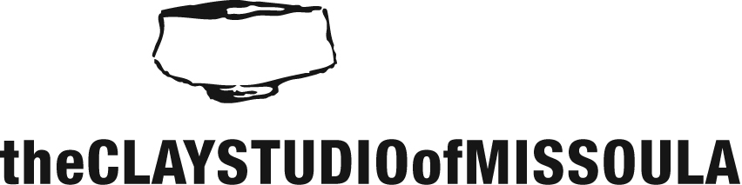

Internship Application

Date: ____________

First Name: ____________________ Last Name:_____________________ Preferred pronouns: ________

Address: ___________________________________________________________________________________

Occupation: __________________________ Date of Birth: ______________

Best contact phone #: ___________________ Email Address: _______________________________________

Please indicate which of the following internship opportunities you are applying for:

Studio Technician
Gallery Intern
Special Event/Fundraising Intern
Grant Writing

If you have any previous work and/or volunteer experience please provide a brief summary:

What types of special skills, educational training, and interests do you possess that might assist you in your internship with The Clay Studio of Missoula?

Which hours and day(s) of the week would you currently be available to fulfill the hours of an internship?

What specific goals/objectives do you have in mind for your internship?

Please list two people (non-relatives) who can provide a reference for you:

Name: ____________________________ relationship: ________________________
Phone: ______________________ email: ________________________

Name: ________________________ relationship: ________________________
Phone: ______________________ email: ________________________

Our internship program is centered on the idea that through mentorship and education individuals can gain a broader understanding of ceramic studio practices. It is the goal of the CSoM to offer this program to individuals who would like to advance their ceramic skill levels with guidance from our studio manager to achieve a greater level of confidence within your studio practice.

Interns will receive:
- One year CSoM membership
- 24hr studio access
- Firing priority (when applicable)
- One shelf to store projects. *If you already have shelving space in our studio, the studio cannot provide more.
- Discounts on classes, workshops, clay, and materials

Please bear in mind that our internship program is not a work study opportunity. All selected interns will have to provide a clear and achievable objective and will need to commit to 5 hours per week to be considered.
Objective examples include:
- Clay and glaze research
- Advancements in studio practices
- Kiln and firing techniques
- Mold making and slip casting

You may submit your application in the following ways
Via email: studiomanager@theclaystudioofmissoula.org
Mail or drop off: The Clay Studio of Missoula, 1106 Hawthorne St, Missoula, MT 59802

